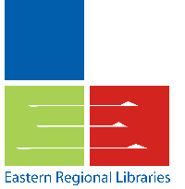
Eastern Regional Libraries
1350 Ferntree Gully Road
Scoresby 3179

Local Primary School
Pilot Authority
Victoria <DATE>

Dear Parent/Guardian

Did you know that children who read for pleasure do better at school?

We’ve partnered with the local library service to provide each child at <school> with their own library membership. This will allow your child to access a vast range of research and literacy tools that we’ll be using in class. Kids can borrow almost 50,000 free ebooks and access several premium online resources including Encyclopedia Britannica and Literacy Planet. Additionally you can visit your local library to activate the borrowing of real books. That’s free too!

Eastern Regional Libraries (ERL) is a Local Government Entity providing library services to the Knox, Maroondah and Yarra Ranges Councils. To create this membership some information, including your child’s name and address, will be shared with the organisation. ERL takes privacy seriously and complies with its obligations under the Privacy and Data Protection Act 2014. For more information please visit www.erl.vic.gov.au

If you do not want your child to receive their FREE library membership to access these study and literacy boosting tools, please complete the form below. No action is required if you would like your child to have a library membership or if your child already has a library card.

Yours sincerely

Jane Bookworm
Librarian

If you DO NOT want your child to receive a library membership please complete this form and return to school by <DATE>

Child’s Name ………………………………………………………………………………… Class …………………………………………

Parent/Guardian Signature …………………………………………………………… Date ………………………….………………

