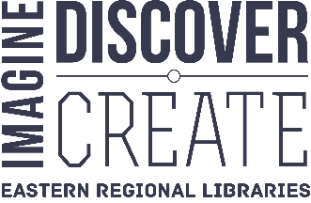
Eastern Regional Libraries
1350 Ferntree Gully Road
Scoresby 3179

Local School
Address Line 1
Victoria <DATE>

Dear Parent/Guardian

Your child can use their CompassIdentity card as a library card!

We’ve partnered with the local library service to allow students to use their CompassIdentity card to access library resources. Please follow the instructions overleaf to activate this service. Doing so will allow your child to access a vast range of research and literacy tools that we’ll be using in class. Kids can borrow almost 50,000 free ebooks and access several premium online resources including Encyclopedia Britannica and Literacy Planet. Additionally, they can borrow books, DVDs, magazines and video games from 14 libraries.

The library service in Knox, Maroondah and Yarra Ranges area is Eastern Regional Libraries, a Local Government Entity that complies with the Privacy and Data Protection Act 2014. If you choose to activate this feature some information about your child will be shared with the library. You’ll also act as guarantor and agree to conditions of membership available at:

www.yourlibrary.com.au

To activate this feature please follow the instructions overleaf.

Yours sincerely

School Representative Name
Local School

Activating Library Services

Introduction:
Students with a CompassIdentity card that says Compass on the back side are able to use that card to access many library services.

Requirements:
- A child with a CompassIdentity card that displays the word Compass in a blue box on the back side
- A computer with access to the Compass School Portal for your child

Procedure:
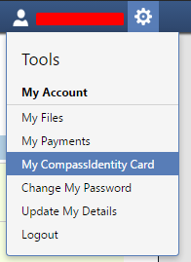
- Visit the Compass School Portal via the normal login URL for the student and log in
<If possible, provide the website address here>
- Click on the cog icon which looks like a gear and takes you to the settings
- Click on My CompassIdentity Card
- Scroll down on the page to the Externally Linked Card Services page and check the box in the row corresponding to your child’s name and the partner service Eastern Regional Library Corporation.
- Read through the permission acceptance screen and approve the use for Compass to send data to the Eastern Regional Library Corporation.
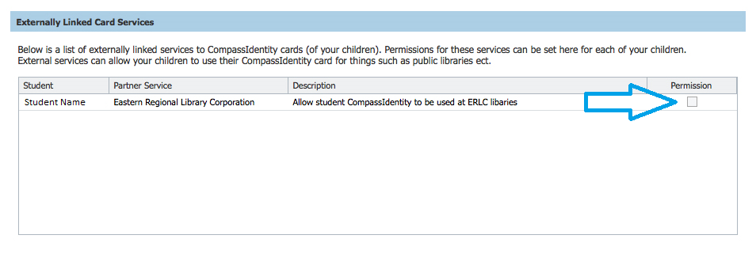
That’s it! The student’s card will now work with most library services including the borrowing of items in branches, downloading 50,000+ ebooks and countless study resources via the library’s website.

Notes:
- Library membership is subject to the membership conditions available at www.yourlibrary.com.au
- Items can be borrowed for three weeks and charges apply to items returned late. Overdue charges are impossible for downloadable items!
- The process above must be repeated each new school year
- When borrowing items from the library, students should use the barcode on the rear of their student card. Additionally, they should use the 10 digit number located on the back of the card when logging into library apps. Some of which require a PIN, this is set to the student’s date of birth formatted DDMMYY. It can be changed online at www.yourlibrary.com.au

